**Statistical Machine Learning Approaches to Liver Disease Prediction**

**TEAM ID: PNT2022TMID04163**

**Team leader:** MOHAMMED ABDUL KHADAR ASHIK S

**Team Membe:** VEERARAJAN R

**Team Member :** SHANTHOSHKUMAR G

**Team Member :** S.ASHVIN BALAJI

**Project Workflow**

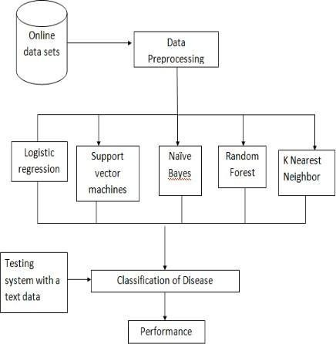

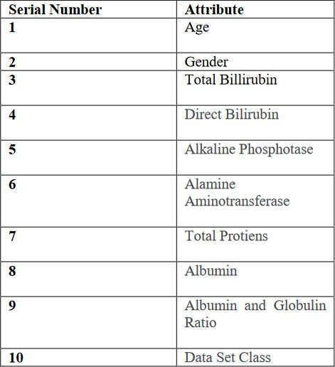

The performance evaluation of various machine learning algorithms like correctly classified instances, incorrectly classified instances, kappa statistic, Mean absolute error (MAE), Root Mean square error (RMSE)are to be

discussed. We are about to do calculation of True positive

rate, False positive rate Precision, Recall, F-Measure, Roc values and confusion matrix of various considered machine learning algorithms.